- INTRODUCTION TO DATA STRUCTURE

1.1 What is Data Structure?
- Data Structure: Data structure is a way to storing and organizing data in a computer so that it can be used efficiently.
- Data structure is used in almost all program and software system.
- Data structure usually consist of two things:
1. The type of structure that we are going to use stores the data.
2. How efficiently we perform operations onto that data stored in structure so we can reduce execution time and amount of memory space.
1.2 Data and Information.
- Data: - Data is a collection of raw facts(or information) and it may or may not be meaningful.
- Information: - meaningful data is known as Information.
- Example:
  - Program- set of instruction.
  - 67.8- Weight of person.
  - 13/3/1999- Date of birth of a person.
1.3 Define following terms:
(a) Cell:
- The smallest fundamental structural unit which represents a data entity.
- Cell is a memory location which stores elements of data items.
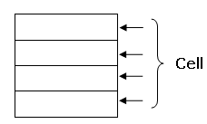

(b) Field: Field is used to store particular kind of data.
(c) Record: a record is a collection of related data items. For example: Employee details

1.4 Types of Data Structure

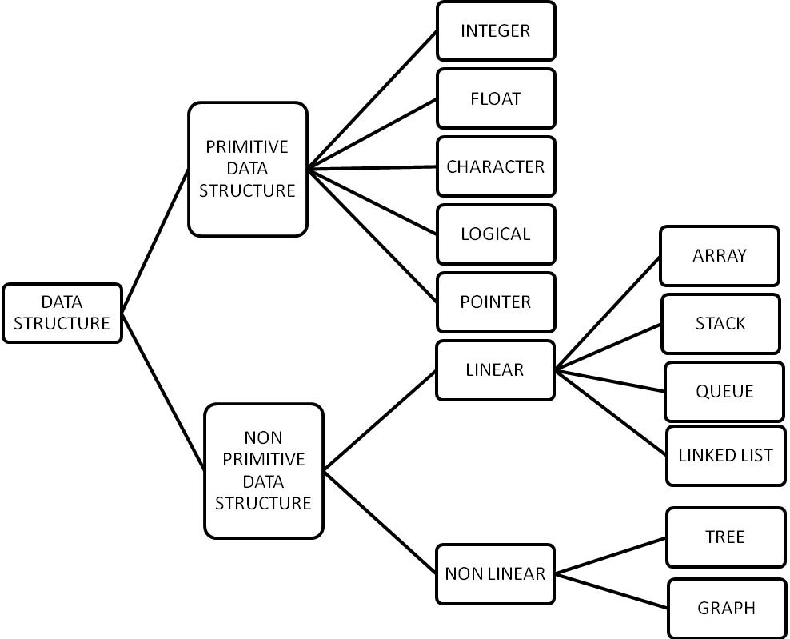

Primitive Data Structure:
- The Data structures that are directly processed by machine using its instructions are known as primitive data structure.
- Following are the primitive data structure:
Integer:
    - Integer represents numerical values which are whole quantities.
    - The number of objects are countable can be represented by an integer.
    - The set of integer is:{…..-(n+1), -n , ….. , -2, -1,0,1,2,………n,n+1}
    - The sign and magnitude method is used to represent integer numbers. In this method place a sign symbol in front of the number.
    - Ex: 1000

Real:
    - The number having fractional part i.e decimal point is called real number.
    - Common way of representing real number is normalized floating point representation.
    - In this method the real number is expressed as a combination of mantissa and exponent.
    - Ex: 123.45
Character:
- Character data structure is used to store nonnumeric information.
- It can be letters [A-Z], [a-z], operators and special symbols.
- A character is represented in memory as a sequence bits.
- Two most commonly known character set supported by computer are ASCII and EBCDIC.
Logical:
- A logical data item is a primitive data structure that can assume the values of either “true” or “false”.
- Most commonly used logical operators Are AND, OR and NOT.
Pointer:
- Pointer is a variable which points to the memory address. This memory address is the location of other variable in memory.
- It provides homogeneous method of referencing any data structure, regardless of the structure’s type or complexity.
- Another characteristic is that it provides faster insertion and deletion of elements.

Non Primitive Data Structure:
- The data structures that are not directly processed by machine using its instructions are known as non primitive data structure.
- Following are the non primitive data structure:
Array:
- Array is an ordered set which consist of a fixed number of object.
- Insertion and deletion operation can be performed on array.
- We can only change the value of the element in array.
List:
- List is an ordered set which consist of variable number of elements or object.
- Insertion and deletion can be performed on list.

File:
- A file is a large list that is stored in the external memory of computer.
- A file may be used as a repository for list items commonly called records.

- Non Primitive Data Structure is classified into two categories:
- Linear Data structure
- Non linear Data structure

1.5 Linear and Non Linear data structure.
Linear Data Structure:
- In the linear data structure processing of data items is possible in linear fashion.
- Data are processed one by one sequentially.
- Examples of the linear data structure are:
(A) Array (B) Stack (C) Queue (D) Linked List

(A) Array: Array is an ordered set which consist of a fixed number of object.
(B) Stack: A stack is a linier list in which insertion and deletion operations are performed at only one end of the list.
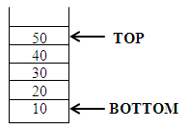

(C) Queue: A queue is a linier list in which insertion is performed at one end called rear and deletion is performed at another end of the list called front.
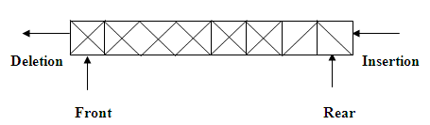

(D) Linked list: A linked list is a collection of nodes.
Each node has two fields:
        - Information
        - Address, which contains the address of the next node.
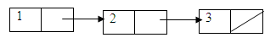
Non Linear data structure:
- In the Non linier data structure processing of data items is not possible in linier fashion.
- Examples of the non linier data structure are:
(A)Tree (B) Graph
(A) Tree: In tree data contains hierarchical relationship.
BSPP

CE
EC
IT

(B) Graph: this data structure contains relationship between pairs of elements.
Delhi
Bombay

Calcutta
Madras

  - Operations on Data Structure:
- Traversing: Access each element of the data structure and doing some processing over the data.
- Inserting: Insertion of new elements into the data structure.
- Deleting: Deletion of specific elements.
- Searching: Searching for a specific element.
- Sorting: Sorting the data in ascending or descending ordered.
- Merging: Combination of two data structure.

  - Algorithms:
- Algorithm is a stepwise solution to a problem.
- Algorithm is a finite set of instructions that is followed to accomplish a particular task.
- In mathematics and computing, an algorithm is a procedure for accomplishing some task which will terminate in a defined end-state.
- The computational complexity and efficient implementation of the algorithm are important in computing, and this depends on suitable data structure.

- Example:
Write Algorithm to compute the average of n elements.
Steps:
ALGORITHM: FIND AVERAGE OF N NUMBER
Assume that array contains n integer values.
- [INITIALIZE] sum ←0.
- [PERFORM SUM OPERATION]
Repeat steps from i=0 to n-1
sum←sum+a[i]
- [CALCULATE AVERAGE]
avg←sum/n
- Write avg
- [FINISHED]
Exit

- Properties required for algorithm.
- Finiteness: “An algorithm must always terminate after a finite number of steps”.
- Definiteness: “Each steps of algorithm must be precisely defined”.
- Input: “quantities which are given to it initially before the algorithm begins”.
- Output: “quantities which have a specified relation to the input”.
- Effectiveness: “all the operations to be performed in the algorithm must be sufficient”.
- Complexity of Algorithms
- Time complexity: Retuning time of the program.
- Space complexity: Amount of computer memory required during the program execution.

1.8 Difference between List and Array
List | Array
(1) No. of elements in a list are not fixed (variable).(Dynamic Data structure) | (1) No. of elements in an array is fixed. (Static Data structure)
(2)It uses pointer variable which occupies an extra memory space. | (2) It does not use pointer variable so it does not occupies extra memory space.
(3) Insertion and deletion operation are very easy to perform. | (3) Insertion and deletion operation are very difficult to perform.
(4) There are two types of List:  1. Linear List  2. Non Linear List | (4) There are two types of array:  1. One dimensional array  2. Two dimensional array
(5) Searching is slower in case of List. | (5) Searching is faster in case of array.

1.9 Difference between Static Memory allocation and Dynamic Memory allocation.
Static Memory Allocation | Dynamic Memory Allocation
(1) Static Memory Allocation is Performed at Compile Time. | (1) Dynamic Memory Allocation is Performed at Runtime.
(2) In Static Memory Allocation Memory may be wasted. | (2) In Dynamic Memory Allocation memory is allocated when it is needed. So there is no wastage of memory.
(3) Array is an example of static memory allocation. | (3) Linked List is an example of dynamic memory allocation. We can use malloc () function to allocate memory at runtime.
(4) In static memory allocation memory is allocated sequentially. | (4) In dynamic memory allocation memory is not allocated sequentially.

INSPIRATIONAL QUOTES:
Nothing can stop the man with the right mental attitude from achieving his goal;
nothing on earth can help the man with the wrong mental attitude.

